ARABIC

Translated by Azza Rathle,
American Women’s Club of Luxembourg.

***********

Students Who Learn Differently Overseas

by Susan van Alsenoy, AWC Antwerp

Email: swl@fawco.org

Page created 10/29/99 EvE. Last updated 03/01/11 SvA.

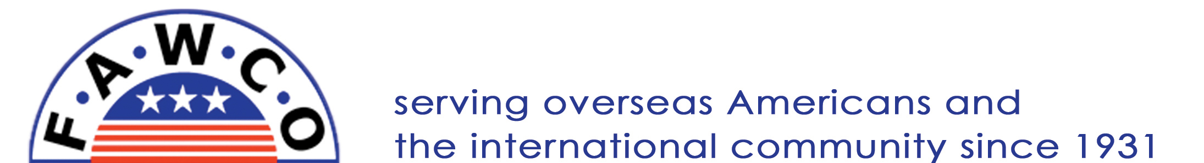

Copyright © fawco.org. All rights reserved.

Home

